Name: Mujahid Ali Rattar

ID: BIT-23F-011

Lab No: 05

Course: Artificial Intelligence

Instructor: Ma’am Aqsa Umar

LAB TASK 05

1. Print Numbers with Loops: Write a program that uses a loop to print numbers from 1 to 10.

Code:

# for Loop

for i in range (1, 11):

print(i)

Output:

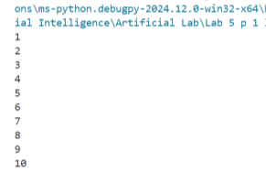

2. Calculate the Sum of Numbers: Write a function that calculates the sum of all numbers up to a given number using a loop.

Code:

# Calculate the Sum of Numbers:

def sum_up_to(n):

total = 0

for i in range (1, n + 1):

total += i

return total

# Example usage

n = 10

print ("\n => Sum of numbers up to", n, "is:", sum_up_to(n))

Output:

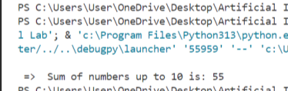

3: Display a Star Pattern: Write code using loops and nested loops to create star pattern(discussed previously).

Code:

# Loop And Nested loop tringle :

r = 6

for i in range(1,r + 1):

for j in range(1,i + 1):

print("*", end="")

print()

print("_________________________________________\n")

Output:

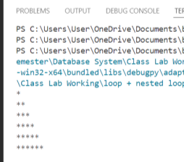

4. Find Even Numbers in a List: Write a function that takes a list of numbers and prints only the even numbers.

Code:

# Find Even Numbers in a List:

def print_even_numbers(numbers):

# Loop through each number in the list

for num in numbers:

# Check if the number is even

if num % 2 == 0:

print(num)

# Example usage

numbers_list = [1, 2, 3, 4, 5, 6, 7, 8, 9, 10]

print_even_numbers(numbers_list)

Output:

